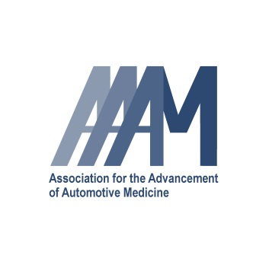

Association for the Advancement of Automotive Medicine

Annual Scientific Conference

AAAM RELEASE FORM
Institutional Review Board (IRB) Approval

The AAAM requires author(s) whose research involved original data collection on human subjects, animals or cadavers to complete this form.

Name of Institution who provided IRB approval

Was informed written consent obtained? ‰ Yes No

If not, was it not required by the IRB organization?

I certify that all procedures involving the use of animal or human subjects, including surveys, conform to the ethical guidelines specified in the country in which this research was performed. 

Yes No Not Applicable

Author(s) Name | Author(s) Signature | Date

Return to: info@aaam.org

Association for the Advancement of Automotive Medicine
35 E Wacker Dr. ● Suite 850 ● Chicago, IL 60601
847-844-3880 ● Fax: 312-644-8557
info@aaam.org ● www.aaam.org

